TRIAL PESA/TESA REPORT
JAYA SUPER-SPECIALTY FERTILITY CENTRE &
CENTRE FOR REPRODUCTIVE GENETICS AND IMMUNOLOGY
Dr. PRIYANKA CHEVUTURI MBBS, MS(OBGYN), M. Ch (REPRODUCTIVE MEDICINE AND SURGERY), REG NO: APMC/FMR/129439
FERTILITY AND REPRODUCTIVE MEDICINE DEPARTMENT

NAME/AGE: | SPOUSE NAME/AGE:
MRD NUMBER: | MRD NUMBER:
HOSPITAL NUMBER: | DATE OF PROCEDURE:
PRELIMINARY EXAMINATION FINDINGS:

TESTIS | SIZE | EPIDIDYMIS | VAS | VARICOCELE  /GRADE | PENILE EXAMINATION | P/R EXAMINATION
RIGHT
LEFT

INDICATION OF THE PROCEDURE:

PROCEDURE DONE:

PROCEUDRE OUTCOME:
Nature of the obtained sperms:
Motile Good morphology
Non-motile Acceptable morph.
Poor morphology
Obtained sperms are cryo-preserved:
Yes
No
 | PESA | TESA | 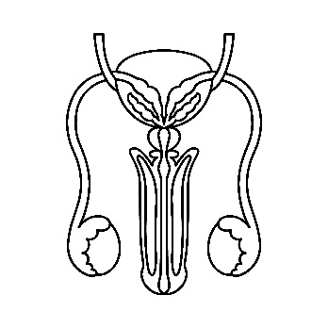
RIGHT | Sperms obtained  Sperms not obtained | Sperms obtained  Sperms not obtained
LEFT | Sperms obtained  Sperms not obtained | Sperms obtained  Sperms not obtained

Dr. PRIYANKA CHEVUTURI MBBS, MS(OBGYN), M. Ch (REPRODUCTIVE MEDICINE AND SURGERY), REG NO: APMC/FMR/129439
FERTILITY AND REPRODUCTIVE MEDICINE DEPARTMENT
JAYA SUPER-SPECIALTY FERTILITY CENTRE & CENTRE FOR REPRODUCTIVE GENETICS AND IMMUNOLOGY

